University of Science & Technology Bannu
Department of Software Engineering,
Faculty of Engineering (FE)

Course Information & Syllabus

BASIC INFORMATION
INSTRUCTOR
Name: Dr. Engr. Javed Khan
Office Location: Faculty Offices, department Of Software Engineering, Faculty of Engineering (FE), main campus, township Bannu, University Of Science and Technology (UST) Bannu.
Email: engryaqoob@hotmail.com
Counseling Hrs: 11:00 am to 01:00 am (Monday & Thursday) (or By appointment)
PROGRAM & DEPARTMENT
Program(s) on which the course is given:
Duration of Program: 18 Weeks (Teaching 16 weeks & Exam 2 weeks)
Dept Offering The Program: Software Engineering
Dept Offering The Course: Software Engineering
Webpage: None
Semester Duration: 18 weeks

COURSE INFORMATION
Code: SE-305 |  | Title: Computer Communication & Networks |  |  | Credit Hrs: 3+1
Pre & Co Requisites:

Pre-Requisites Courses: None

Co-Requisites Courses: None

Pre-Requisites by Topics: None

Course Outcome:
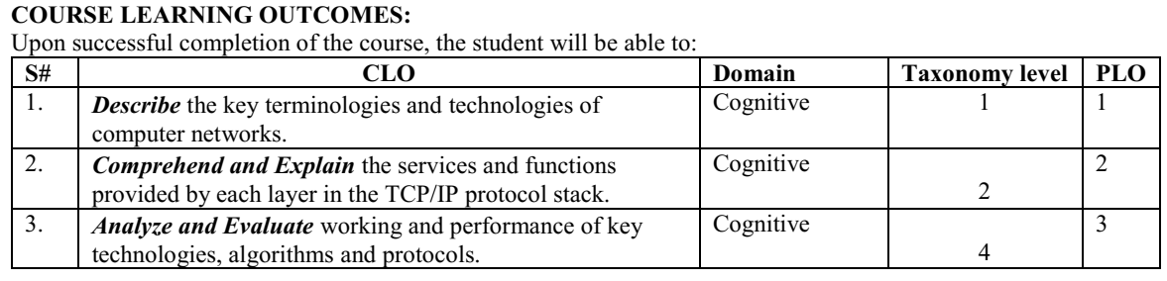

Course Outlines:
Introduction and protocols architecture, basic concepts of networking, network topologies, layered architecture, physical layer functionality, data link layer functionality, multiple access techniques, circuit switching and packet switching, LAN technologies, wireless networks, MAC addressing, networking devices, network layer protocols, IPv4 and IPv6, IP addressing, sub netting, CIDR, routing protocols, transport layer protocols, ports and sockets, connection establishment, flow and congestion control, application layer protocols, latest trends in computer networks.

Text & Reference books:
- Computer Networking: A Top-Down Approach, By: Kurose and Ross, Edition: 7th, Publisher: Pearson, ISBN: 9780133594140/ ISBN 0133594149, Year of Publication: 2017.
- Data and Computer Communication, By: William Stallings, Edition: 10th, Publisher: Prentice Hall, ISBN: 0133506487, Year of Publication: 2013.
- Introduction to Computer Networks, By: A. S. Tanenbaum and David J. Wetherhall, Edition: 5th, Publisher: Prentice Hall, ISBN: 0132126958, Year of Publication: 2010.
- Data Communications and Networking, by Behrouz A. Forouzan, 5th edition, 2013

TEACHING AND ASSESSMENT POLICY
Teaching:
- Lectures: 48
Teaching Methodology
- Lecturing, Written Assignments, Quizzes
Grading Policy
- Assignments = 10 %
- Quizzes = 10 %
- Mid-Term Exam = 30 %
- Final-Term Exam = 50 %
- Above policy for grading can be changed latterly.
Assignment Policy
There will be total of 3 to 6 Assignments. Assignments will be graded based on accuracy, method used and organization/neatness. Late Assignment without any valid reason will not be accepted.

Quiz Policy
There will be 4 to 6 quizzes in the semester. Failure to take quiz without a valid reason will result in a score of zero.
WEEKLY & LECTURE-WISE COURSE BREAKDOWN
(Subject to Change)
Week No | Topics/Activities |  | Book Reading | Notes
1 | Introduction and protocols architecture, basic concepts of networking, network topologies
2 | layered architecture |  | A1-CLO1 | Q1-CLO1
3 | physical layer functionality
4 | Introduction to wireless networks
5 | Application layer protocols  (Web and HTTP  E-mail, SMTP, IMAP |  |  | Q2-CLO2
6 | The Domain Name System DNS  P2P applications
7 | video streaming and content distribution networks (CDN)  transport layer protocols
8 | ports and sockets, connection establishment, multiplexing, demultiplexing |  | A2-CLO2
9 | MID EXAM
10 | reliable data transfer, flow and congestion control
11 | networking devices, network layer protocols, IPv4 and IPv6,
12 | IP addressing, sub netting, CIDR,
13 | routing protocols, forwarding versus routing, how a router works ,data plane, control plane
14 | Switching technique (circuit switching and packet switching), data link layer functionality, error detection, correction, address resolution protocol (ARP) |  | A3-CLO2
15 | multiple access techniques  (TDMA FDMA CDMA  ALOHA(Additive Links On-line Hawaii Area), slotted ALOHA  CSMA, CSMA/CD, CSMA/CA  Taking turns ) |  | A4-CLO3 | Q3-CLO2
16 | LAN technologies, MAC addressing |  | A5-CLO3
17 | Revision |  |  | Q4-CLO3
18 | Final Term Exam

Instructor: _____________________

